Cyber Defence Incident Report
  - Windows and MySQL honeypot compromise
  - Cyber Range – SOC Training | 14–19 September 2026

1 Executive summary
The internet-exposed Windows VM corp-neo10-f777 and its MySQL service were successfully compromised. MySQL root access was followed by database enumeration, reads against the credentials, customers, orders, and payments tables, destructive DROP DATABASE commands, creation of a ransom database, and an extortion note. Separately, the Windows administrator account received successful remote logons and later executed Masscan/WinPcap tooling, modified the Windows executable-handler registry key, and launched an RDP/3389 scanning command. DeviceNetworkEvents review identified eight failed outbound RDP attempts from the compromised Administrator context to private network hosts, together with successful outbound communications initiated by ._cache_Massscan_GUI.exe and the suspicious Synaptics.exe process. This confirms attempted lateral movement and post-compromise network activity; successful lateral compromise, confirmed command-and-control (C2), and data exfiltration remain not established.
The pre- and post-breach Microsoft Defender for Endpoint (MDE) investigation packages independently support the host findings. New Masscan, WinPcap/NPF, svchost.com and Synaptics.exe artifacts indicate post-compromise execution and scanning capability. The overall assessment is confirmed compromise with high confidence.
Incident attribute | Assessment
Environment | Internet-exposed honeypot in a controlled cyber range
Affected systems | Windows VM: corp-neo10-f777  MySQL logging resource: corp-neo10-f777m
Affected accounts | Windows local administrator; MySQL root
Classification | Unauthorised privileged access, destructive database-extortion activity and post-compromise host activity
Severity | High analyst-assessed severity; original Sentinel alert severity: Medium
Detection | Reviewed alert: 16 September 2026 at 22:38:10, following the 22:26:18 Administrator logon. This is not the earliest incident activity; MDE export timezone is not encoded.
Reporter | Not determined from available logs.
Response status | Compromised VM isolated and destroyed; replacement deployed and hardened. Recovery screenshot records a completed full scan with zero threats found.

Scope and interpretation
This report combines endpoint and MySQL telemetry, incident-response evidence and the investigation-package comparison. It documents a honeypot exercise; production business loss is not established. Attempted lateral movement was observed through failed RDP connections from the compromised host to multiple private network addresses. Successful lateral compromise, confirmed command-and-control (C2), data exfiltration and file-encryption ransomware are not established by the available evidence. Figures 1–14 illustrate selected findings and response actions.

Detection and exposure evidence
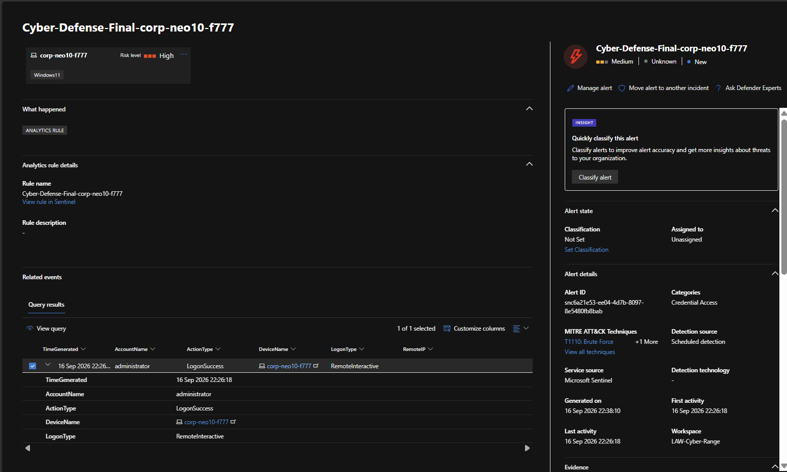
Figure 1. Sentinel alert for a successful Administrator remote-interactive logon. The reviewed alert was generated at 22:38:10 on 16 September 2026.
Source: P7-01 - Sentinel Alert Triage - Successful Administrator Logon.png
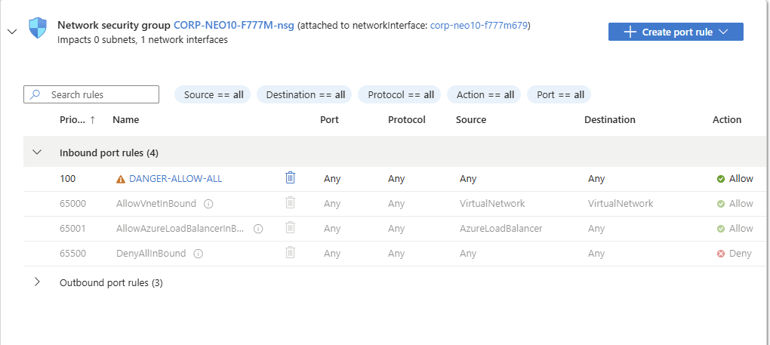
Figure 2. The deliberately permissive DANGER-ALLOW-ALL inbound rule in the honeypot NSG before containment.
Source: P5-11 - Azure NSG Allow All Inbound Rule.png

2 Impact and initial access

Confidentiality
The MySQL logs show SELECT * queries against credentials, customers, orders, and payments. Whether returned data was actually exfiltrated is not determined from available logs. DeviceNetworkEvents additionally records outbound communications from the suspicious Synaptics.exe process to external infrastructure, including freedns.afraid.org and Google-hosted services. The telemetry establishes that network communication occurred but does not reveal the content transferred; data exfiltration is therefore not determined from available logs.

Integrity
SQL statements attempted to drop xm_corp01, sakila, world, and the existing ransom database. The attacker/script then recreated RECOVER_YOUR_DATA and inserted an extortion message. On the Windows host, HKLM\SOFTWARE\Classes\exefile\shell\open\command was changed to route executable launches through C:\Windows\svchost.com.

Availability
A MySQL SHUTDOWN statement was issued and databases were targeted for deletion. Exact service downtime is not determined from available logs. The Windows host was ultimately considered untrustworthy and rebuilt.

Scope
Evidence confirms compromise of the honeypot VM and its local MySQL service. DeviceNetworkEvents further records eight RDP connection attempts from the compromised host to private network addresses under the Administrator context. All eight recorded attempts failed, supporting attempted lateral movement but not successful lateral compromise. Successful compromise of another system is not determined from available logs.

Root cause and attack vector
The primary enabling condition was public exposure of privileged services combined with deliberately weak privileged authentication in the honeypot configuration.
MySQL shows repeated external probing followed by successful root authentication. Windows telemetry shows successful external use of the local administrator account, including RemoteInteractive sessions. DeviceNetworkEvents records 390 accepted inbound connection events on local TCP/3389 from 266 unique remote IPs and 99 accepted inbound connection events on local TCP/3306 from 89 unique remote IPs in the reviewed export. These are connection-level events and do not independently establish successful authentication.
Following privileged Windows access, mstsc.exe running under the administrator account attempted RDP connections from 10.1.0.10 to eight private network addresses. All observed connection attempts returned ConnectionFailed. This behaviour is consistent with attempted lateral movement over RDP; no successful lateral session was identified in the reviewed network telemetry.
The exact password submitted by the attacker is not determined from available logs. No evidence in the supplied logs indicates exploitation of a specific Windows or MySQL software vulnerability.
The reviewed DeviceLogonEvents CSV contains successful events only. Phase 6 screenshots show additional failed logons; the complete Windows brute-force sequence is not determined from the reviewed evidence.

Timestamp conventions
MySQL RawData contains UTC timestamps that are one hour behind the exported TimeGenerated field. MySQL timeline entries below use the embedded UTC timestamp. MDE CSV timestamps are reported as exported because the files do not encode a timezone.
All timeline dates are in September 2026. Entries marked UTC use the recorded UTC basis; endpoint events retain their exported time. Cross-source ordering must account for the unresolved MDE timezone.

Database compromise evidence
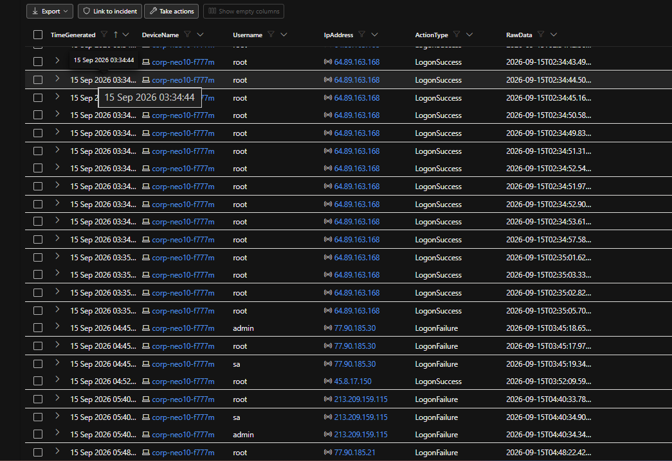
Figure 3. MySQL authentication results include successful root connections from 64.89.163.168 and other external sources, alongside failed connections.
Source: P6-02 - MySQL Failed and Successful Root Logons.png
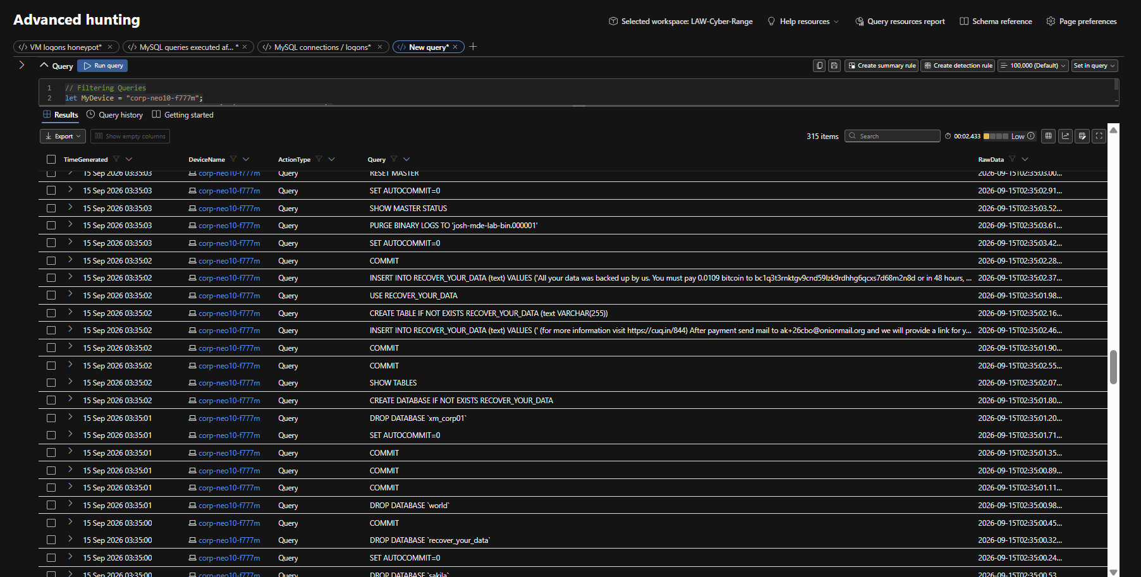
Figure 4. SQL audit results show DROP DATABASE statements, creation of RECOVER_YOUR_DATA and ransom-note insertion. Displayed query text is partly truncated.
Source: P7-08 - MySQL Commands - Database Drops and Ransom Note.png

3 Indicators and investigative artifacts
The following values were observed in the investigation. Source IPs identify recorded connections and are not, by themselves, attribution to a person or a single campaign. Legitimate tools such as WinPcap require the surrounding execution context for interpretation.
Type | Observed value | Context
BTC address | bc1q3t3rnktgv9cnd59lzk9rdhhg6qcxs7d68m2n8d | 0.0109 BTC ransom demand
Email | ak+26cbo@onionmail.org | Extortion contact
URL | hxxps://cuq[.]in/844 | Reference URL in ransom note (defanged)
DATAID | 26CBO | Ransom-note identifier
Windows source IPs | 41.251.170.255  219.78.203.111  80.94.95.83  190.12.196.182  80.66.83.80  141.98.80.88  41.38.5.6  109.195.19.54 | External IPs observed on successful Administrator events; attribution varies
MySQL successful-root IPs | 64.89.163.168 | 45.8.17.150 | 64.89.163.94 | 64.89.163.154 | 64.89.163.178 | 77.90.185.30 | 77.90.185.21 | 64.89.163.158 | 64.89.163.170 | 64.89.163.179 | 64.89.163.93 | 213.209.159.115 | 89.248.172.33 | 64.89.163.89 | Explicit successful root@IP connections
File | C:\Windows\svchost.com | Suspicious executable masquerading as svchost.exe
Tooling | Massscan_GUI.exe, masscan.exe, ._cache_masscan.exe | Network scanning
Tooling | WinPcap_4_1_3.exe, npf.sys | Packet-capture/scanning dependency
File | C:\ProgramData\Synaptics\Synaptics.exe | Suspicious artifact launched by Masscan GUI; exact role not determined
Registry | HKLM\SOFTWARE\Classes\exefile\shell\open\command → C:\Windows\svchost.com "%1" %* | Executable file-association hijack
Network destination | 51.15.12.186 / www.ipdeny.com | Successful TCP/80 and TCP/443 connections initiated by ._cache_Massscan_GUI.exe; contextual network indicator, not independently established as malicious infrastructure
Network destination | 67.220.81.150 / freedns.afraid.org | Successful TCP/80 connection initiated by C:\ProgramData\Synaptics\Synaptics.exe; contextual network indicator
Internal RDP targets | 10.1.0.4 | 10.1.0.5 | 10.1.0.6 | 10.1.0.7 | 10.1.0.8 | 10.1.0.9 | 10.1.0.11 | 10.0.0.4 | Targets of failed RDP connection attempts from mstsc.exe under the Administrator account
Additional package artifacts: ._cache_Massscan_GUI.exe and the WinPcap rpcapd service. Reliable cryptographic hashes were not available; the packages did not provide suitable copies of the suspicious binaries.

4 Incident timeline
Recorded time | Activity | Evidence source
14 Sep 2026 22:14:02 UTC | Recorded lab exposure point used as investigation start time. | Lab investigation marker
15 Sep 00:59:51 UTC | First exported MySQL probe: failed root connection from 64.89.163.152. | MySQL authentication CSV
15 Sep 02:34:29 UTC | First explicit successful MySQL root login from 64.89.163.168. | MySQL authentication CSV
15 Sep 02:34:56–02:34:59 UTC | xm_corp01 enumerated; credentials, customers, orders, and payments queried. | MySQL query CSV
15 Sep 02:35:00–02:35:01 UTC | DROP DATABASE issued for recover_your_data, sakila, world, and xm_corp01. | MySQL query CSV
15 Sep 02:35:01–02:35:02 UTC | RECOVER_YOUR_DATA recreated and ransom note inserted with BTC address, email, URL and DATAID. | MySQL query CSV
15 Sep 02:35:03–02:35:05 UTC | RESET MASTER, binary-log purge, root privilege manipulation and SHUTDOWN issued. | MySQL query CSV
15 Sep 12:29:06 | Successful RemoteInteractive Administrator event associated with 41.251.170.255. | DeviceLogonEvents
15 Sep 12:32:30–12:32:51 | mstsc.exe, running as Administrator, attempted RDP connections from 10.1.0.10 to eight private addresses across the 10.1.0.0/24 and 10.0.0.0/24 networks. All recorded connections failed. | DeviceNetworkEvents
16 Sep 22:26:18 | Successful RemoteInteractive Administrator access from 141.98.80.88. | DeviceLogonEvents
16 Sep ~22:38 | Sentinel scheduled detection generated for successful Administrator access. | Defender incident evidence
17 Sep 06:35–06:40 | Further Administrator session activity temporally associated with 109.195.19.54. | DeviceLogonEvents
17 Sep 06:41:58 | Massscan_GUI.exe executed under Administrator. | DeviceProcessEvents
17 Sep 06:42:05 | Synaptics.exe InjUpdate launched by Masscan GUI. | DeviceProcessEvents
17 Sep 06:42:07 | ._cache_Massscan_GUI.exe made successful TCP/80 and TCP/443 connections to www.ipdeny.com (51.15.12.186). | DeviceNetworkEvents
17 Sep 06:42:07 | Synaptics.exe running as Administrator made a successful TCP/80 connection to freedns.afraid.org (67.220.81.150). | DeviceNetworkEvents
17 Sep 06:42:32–06:42:39 | WinPcap executed; net start npf and net1 start npf commands issued. | DeviceProcessEvents
17 Sep 06:42:33 | exefile\shell\open\command changed to C:\Windows\svchost.com "%1" %*. | DeviceRegistryEvents
17 Sep 06:42:51–06:42:52 | Masscan launched with -p3389 --rate 100000 -iL Input.txt -oL Output.txt. | DeviceProcessEvents
17 Sep 06:43:06 | Synaptics.exe made additional successful connections to Google-hosted infrastructure, including docs.google.com and drive.usercontent.google.com. The purpose and transferred content are not determined from available logs. | DeviceNetworkEvents
18 Sep | VM isolated in Defender and post-breach investigation package collected. | Defender response evidence
18–19 Sep | Compromised VM ultimately destroyed; clean replacement VM deployed and hardened; MySQL repopulated from clean source data. | Recovery evidence
UTC is stated where established. Unmarked endpoint times retain the export timezone, which is unknown. SQL audit statements demonstrate commands issued; they do not independently prove every command succeeded.

Windows logon and execution evidence
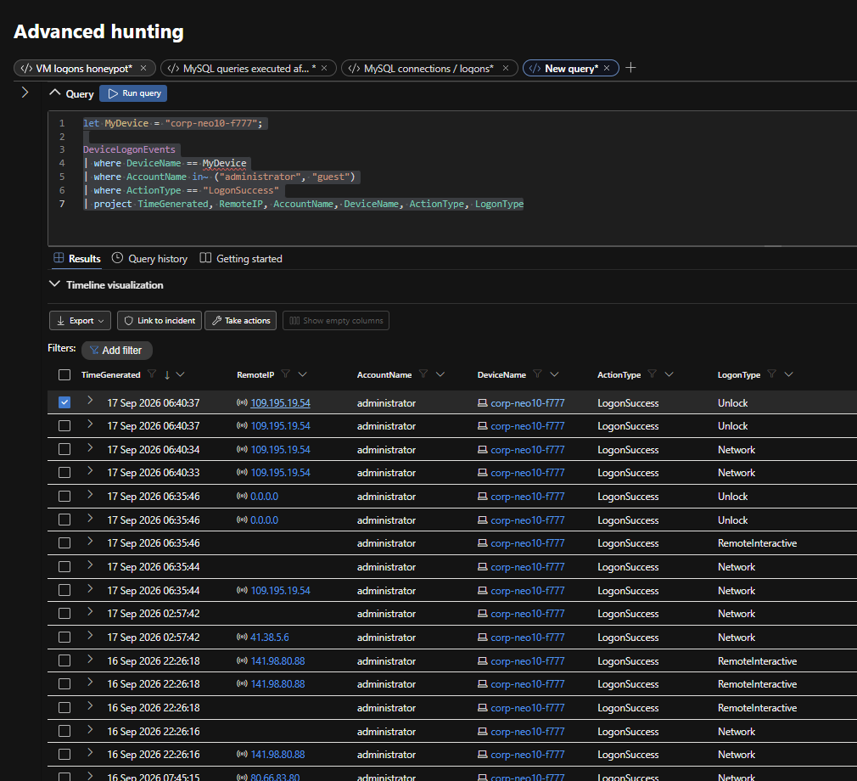
Figure 5. Successful Administrator sessions include remote source IPs. The screenshot supports session context; it does not identify the operator.
Source: P7-02 - Source IP Confirmed for Successful Administrator Logon.png
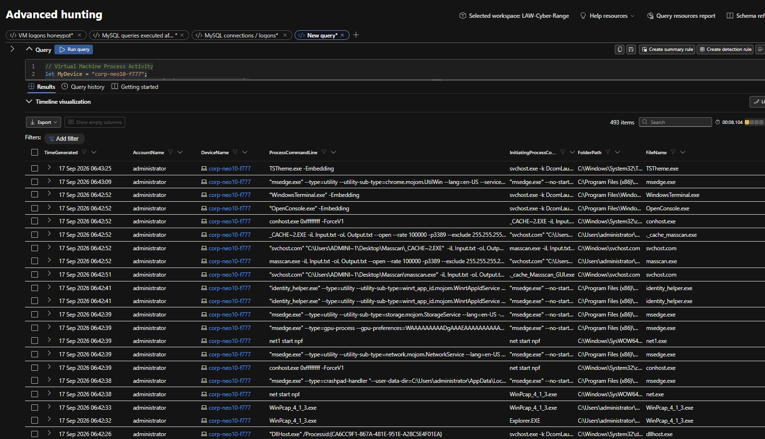
Figure 6. Process results show Masscan command lines targeting port 3389, svchost.com execution, WinPcap and net start npf.
Source: P7-15 - Process Results - Masscan and WinPcap Activity.png

5 Forensic package comparison
Both packages identify CORP-NEO10-F777. Internal collection metadata establishes the baseline and comparison order.
Role | Package | Collection began in UTC
Baseline | Pre-investigation package.zip | 2026-09-14 22:09:25
Comparison | Post-Breach.zip | 2026-09-18 21:28:13
Source: Forensics Collection Summary.csv in each package. The earliest capture predates the recorded exposure point and is the pre-exposure comparison baseline. Absence of the later indicators in that capture does not prove the absence of all possible compromise.

Notable additions
Added artifact | Assessment | Package evidence
._cache_Massscan_GUI.exe | Suspicious | Post-breach Administrator temp-directory artifacts
MASSCAN.EXE-79AA1496.pf | Suspicious | Post-breach Prefetch list
MASSSCAN_GUI.EXE-AEDB5429.pf | Suspicious | Post-breach Prefetch list
SVCHOST.COM-1CC1F227.pf | Suspicious | Post-breach Prefetch list
SYNAPTICS.EXE-D47F22FF.pf | Suspicious / unresolved | Post-breach Prefetch list
WINPCAP_4_1_3.EXE-17ACA15B.pf  WINPCAP_4_1_3.EXE-2D61599E.pf | Suspicious in context | Post-breach Prefetch list
Masscan / WinPcap paths | Suspicious | Post-breach Autoruns
NPF → system32\drivers\npf.sys | Suspicious in context | Post-breach Autoruns
rpcapd / WinPcap Remote Packet Capture | Suspicious in context | Post-breach Autoruns / Services

Interpretation
Masscan and its GUI execution artifacts corroborate the process telemetry showing attempted RDP scanning. WinPcap, the NPF driver and rpcapd service are legitimate components in isolation, but their introduction alongside Masscan is suspicious in this incident.
The svchost.com Prefetch artifact is significant because the name resembles the legitimate svchost.exe, and endpoint telemetry shows C:\Windows\svchost.com inserted into executable launch handling. Synaptics.exe has execution evidence, but its precise function remains unresolved.
No Masscan, WinPcap, svchost.com or Synaptics.exe process was active at the point of post-breach collection. Historical execution evidence remains relevant despite the absence of a running process.

6 Artifact category assessment
Artifact category | Comparison result | Assessment and limitation
Autoruns and persistence | Added or changed | New NPF and rpcapd entries and Masscan/WinPcap execution artifacts. Endpoint telemetry separately records executable-association modification. Service presence does not by itself establish malicious persistence.
Processes and modules | Historical execution | No named suspicious process active at collection. Prefetch and execution artifacts support earlier activity.
Services and drivers | Added | NPF, npf.sys and WinPcap rpcapd absent from the baseline; suspicious in the scanning context.
Scheduled tasks | Added | OneDrive and SoftLanding-related tasks appeared. No attacker-associated command or suspicious executable path identified; assessed as benign or expected.
Network listeners | Unchanged listeners | RDP/3389 and MySQL/3306 present in both captures. Snapshot connections do not establish C2 or exfiltration.
Local users and groups | No meaningful delta | No new privileged account identified; existing administrative accounts remained.
Security event log | Changed | Security.evtx changed as expected. Basic string inspection found 109.195.19.54 in the later capture only. Security.txt was empty and EVTX was not fully parsed. No log clearing established.
File system and Prefetch | Added | New MASSCAN.EXE, MASSSCAN_GUI.EXE, SVCHOST.COM, SYNAPTICS.EXE and WINPCAP_4_1_3.EXE entries. Strong historical execution evidence.
Installed programs | Added in registry | InstalledPrograms.csv is unchanged, but the 32-bit uninstall registry adds WinPcap 4.1.3, corroborating installation. The inventory alone is incomplete.
Hosts and DNS | Inconclusive | No useful malicious DNS indicator identified; hosts-file comparison unavailable.
Firewall | Collection gap | pfirewall.log unavailable in both packages. Firewall-rule changes cannot be established from that missing log.
Browser and credentials | Insufficient artifacts | Browser history and credential-store evidence incomplete; conclusions not determined.
Routine operating-system churn was excluded from suspicious findings. No specific suspicious removal was established in the comparison; incomplete or missing artifacts are collection limitations, not proof of deletion.

7 Attack technique mapping and evidential limits
The mappings below describe the behaviours supported by the reported evidence. Capability, execution and successful outcomes are distinguished.
Evidence | Tactic or context | Technique assessment
Masscan execution | Discovery | T1046 – Network Service Discovery; execution and command-line evidence support attempted scanning, but DeviceNetworkEvents does not directly establish successful Masscan connections to TCP/3389
Massscan GUI execution | Execution and discovery | Supports the T1046 finding
svchost.com | Defense evasion | T1036 – Masquerading; consistent with the misleading executable name
NPF and WinPcap installation | Discovery support | Enables packet capture and scanning; installation alone does not establish packet capture occurred
rpcapd service | Persistence-capable component | Context-dependent; no additional specific technique established
Synaptics.exe | Execution | Exact technique and function not determined
Administrator mstsc.exe attempts to multiple private hosts | Lateral movement | T1021.001 – Remote Services: Remote Desktop Protocol. Attempted lateral movement observed; all recorded connections failed

Evidence gaps
- DeviceNetworkEvents was reviewed for the incident window. It confirms failed outbound RDP attempts to private hosts and successful outbound communications initiated by suspicious post-compromise processes. The telemetry does not establish successful lateral access, directly demonstrate successful TCP/3389 connections initiated by masscan.exe, reveal transferred network content, or establish confirmed C2 or data exfiltration. NTANetAnalytics was not reviewed.
- The replacement VM reused the endpoint naming convention and appears in the network export with local IP 10.1.0.105. Compromise-related network findings were therefore scoped to the original host at 10.1.0.10; replacement-host traffic was not treated as attacker activity.
- The reviewed Windows logon CSV contains successful events only. Phase 6 screenshots also show failed logons, but the complete brute-force sequence and the exact password used remain undetermined.
- Suspicious binaries were unavailable for static analysis and reliable hash generation.
- Security.evtx was not fully parsed; Security.txt was empty. System and Application EVTX logs were unavailable for full comparison. Basic binary-string matches are insufficient for primary attribution.
- Firewall logging, hosts-file comparison, browser history and credential-store evidence were unavailable or incomplete.
- Prefetch supports historical execution but does not independently establish the operator, complete command line or outcome. Absence of an active malicious connection at collection does not exclude earlier activity.
- The recovery screenshot records a completed full scan with zero threats found. Its displayed timestamp does not include a timezone, and the image does not display a hostname.

Overall assessment
Confirmed compromise – high confidence. Database audit activity and endpoint telemetry establish privileged access and destructive database-extortion activity. DeviceNetworkEvents additionally confirms attempted RDP lateral movement from the compromised host and successful outbound communications initiated by suspicious post-compromise processes, including ._cache_Massscan_GUI.exe and Synaptics.exe. The forensic package comparison independently corroborates post-compromise execution, suspicious system modification and network-scanning capability. Successful lateral compromise, confirmed C2, data exfiltration and file encryption remain unestablished.

8 Response and recovery

Containment
The compromised VM was isolated through Microsoft Defender and a post-breach investigation package was collected. Figures 7–8 show isolation and package availability. A later screenshot records release from isolation pending as remediation began.

Eradication
The permissive DANGER-ALLOW-ALL NSG rule was removed. The weak Administrator account was removed, Guest was disabled, and local credentials were hardened. Because the compromised system exhibited broken executable handling consistent with the malicious registry modification, the VM was not trusted for continued use and was destroyed.

Recovery
A clean replacement VM was deployed and onboarded to Defender. MySQL was reinstalled with a strong root password; the observed replacement configuration restricts root to localhost. The corporate lab database was repopulated from the original clean dataset, the NSG was hardened, and Windows Firewall was enabled for all profiles. Figures 9–13 document onboarding and the replacement security configuration.

Recovery verification
The Phase 9 recovery screenshot records a completed Defender full scan with 0 threats found across 802,385 files. The scan lasted 51 minutes 42 seconds; the displayed last-scan time is 18 September 2026 at 23:37 (timezone not shown). This supports the recovery malware check at that point in time; it does not establish the absence of every possible threat (Figure 14).
Post-containment log review should confirm that attacker logons to the old host ceased. A lack of subsequent logons alone is insufficient to demonstrate that all containment and recovery controls were effective.

Prioritised recommendations
- P1 — Remove direct public access to privileged services. Do not expose MySQL/3306 or unrestricted RDP to the internet; restrict NSGs to approved management paths such as Bastion/VPN.
- P1 — Enforce strong privileged credentials. Remove unnecessary local Administrator-style accounts, keep Guest disabled, and use unique strong credentials for Windows and MySQL privileged accounts.
- P1 — Alert on successful privileged access from external IPs. Successful RemoteInteractive Administrator access and external MySQL root logins should generate immediate high-priority investigation.
- P2 — Detect destructive DB activity. Alert on DROP DATABASE, RESET MASTER, binary-log purge, unexpected privilege changes, SHUTDOWN, and creation of ransom-style schemas such as RECOVER_YOUR_DATA.
- P2 — Detect post-compromise tooling/persistence. Alert on Masscan, unusual packet-capture driver installation, execution of .com files from C:\Windows, and changes to exefile\shell\open\command.
- P2 — Preserve comprehensive network telemetry. Retain DeviceNetworkEvents and, where available, NTA telemetry as part of incident evidence so process execution, authentication activity, attempted lateral movement, C2 indicators and potential exfiltration can be correlated across data sources.

Containment and evidence preservation
The screenshots distinguish confirmed isolation and available forensic collection from a later remediation request that had not yet completed in the captured view.
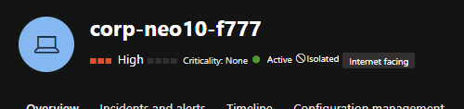
Figure 7. Defender shows corp-neo10-f777 in the Isolated state.
Source: P8-02 - Defender Device Isolation Confirmed.png
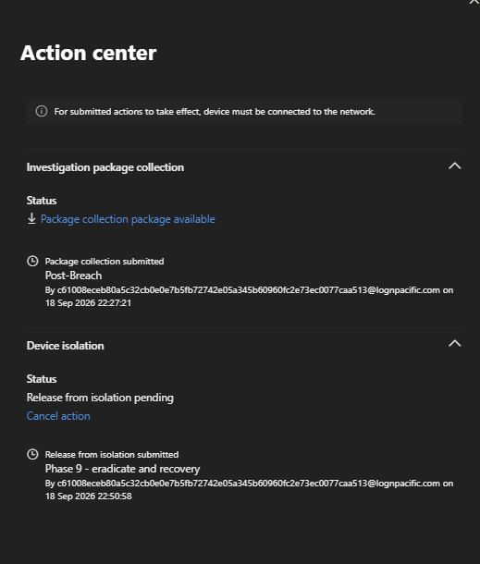
Figure 8. The post-breach investigation package is available. A subsequent release-from-isolation request is shown as pending.
Source: P9-03 - Release from Isolation Pending.png

Replacement host and network controls
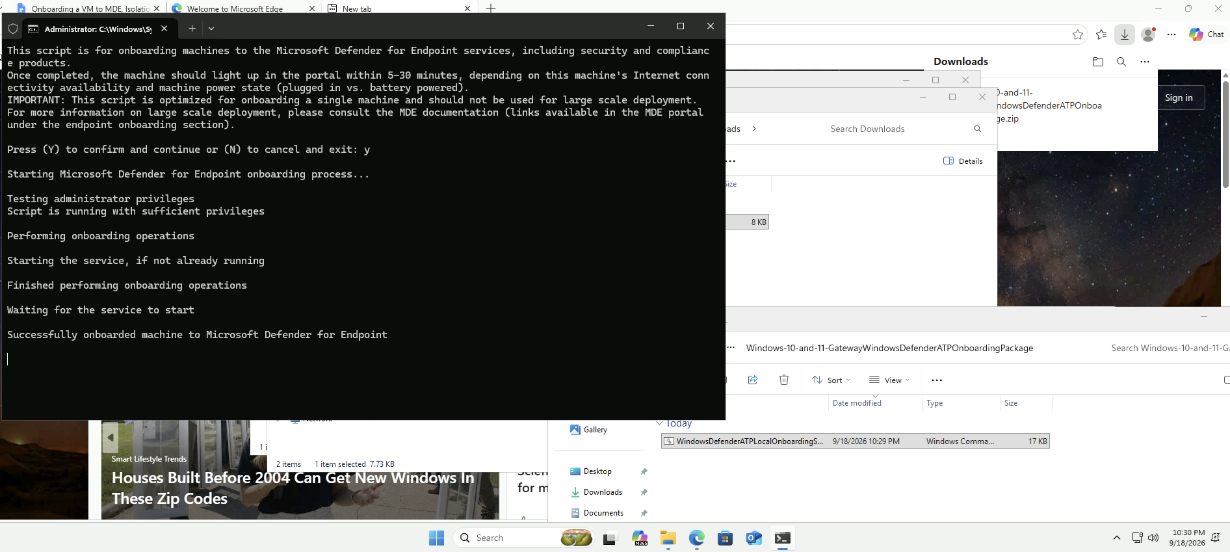
Figure 9. The onboarding script reports successful Microsoft Defender for Endpoint onboarding during the replacement-host recovery sequence.
Source: P9-12 - Clean Replacement VM Deployed.png
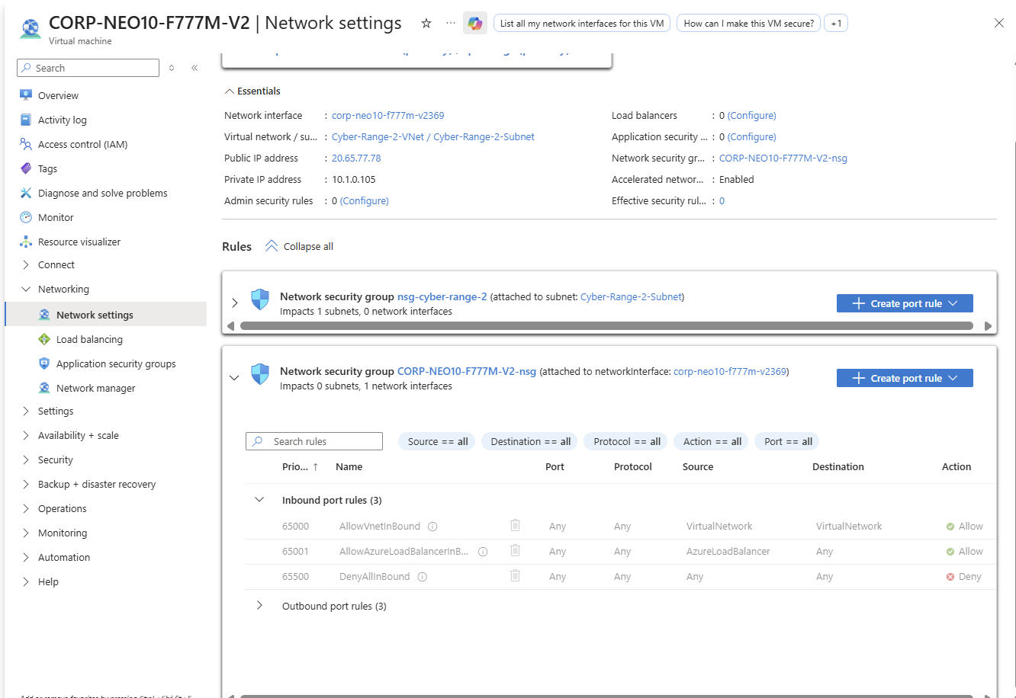
Figure 10. Replacement VM CORP-NEO10-F777M-V2 shows default NIC-level NSG rules, including DenyAllInBound, without the earlier allow-all rule. Subnet-level rules are collapsed in this view.
Source: P9-16 - Replacement VM NSG Hardened.png

Firewall and database access controls
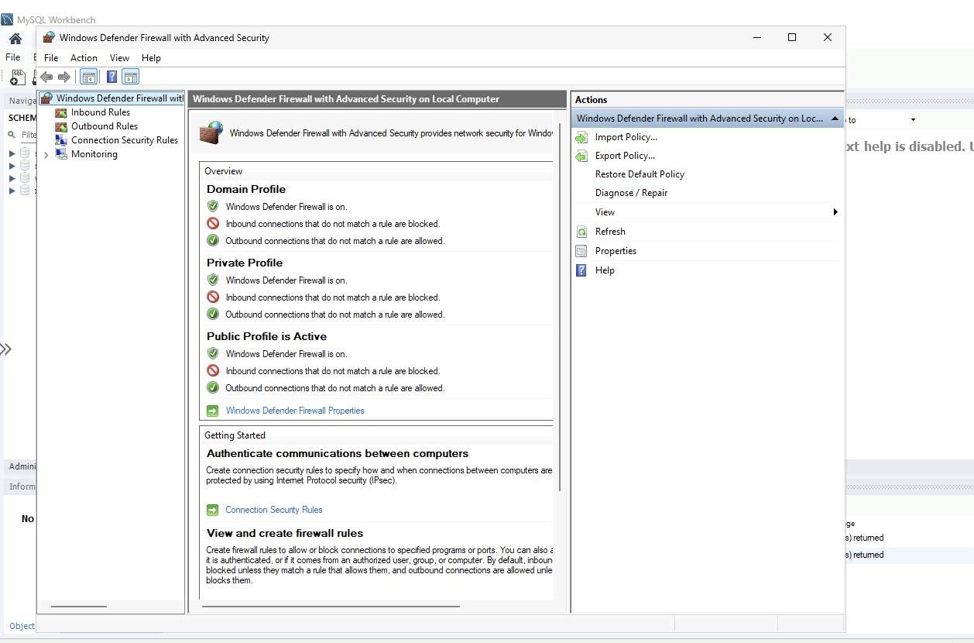
Figure 11. Windows Defender Firewall is enabled for the Domain, Private and Public profiles.
Source: P9-17 - Windows Firewall Enabled.png
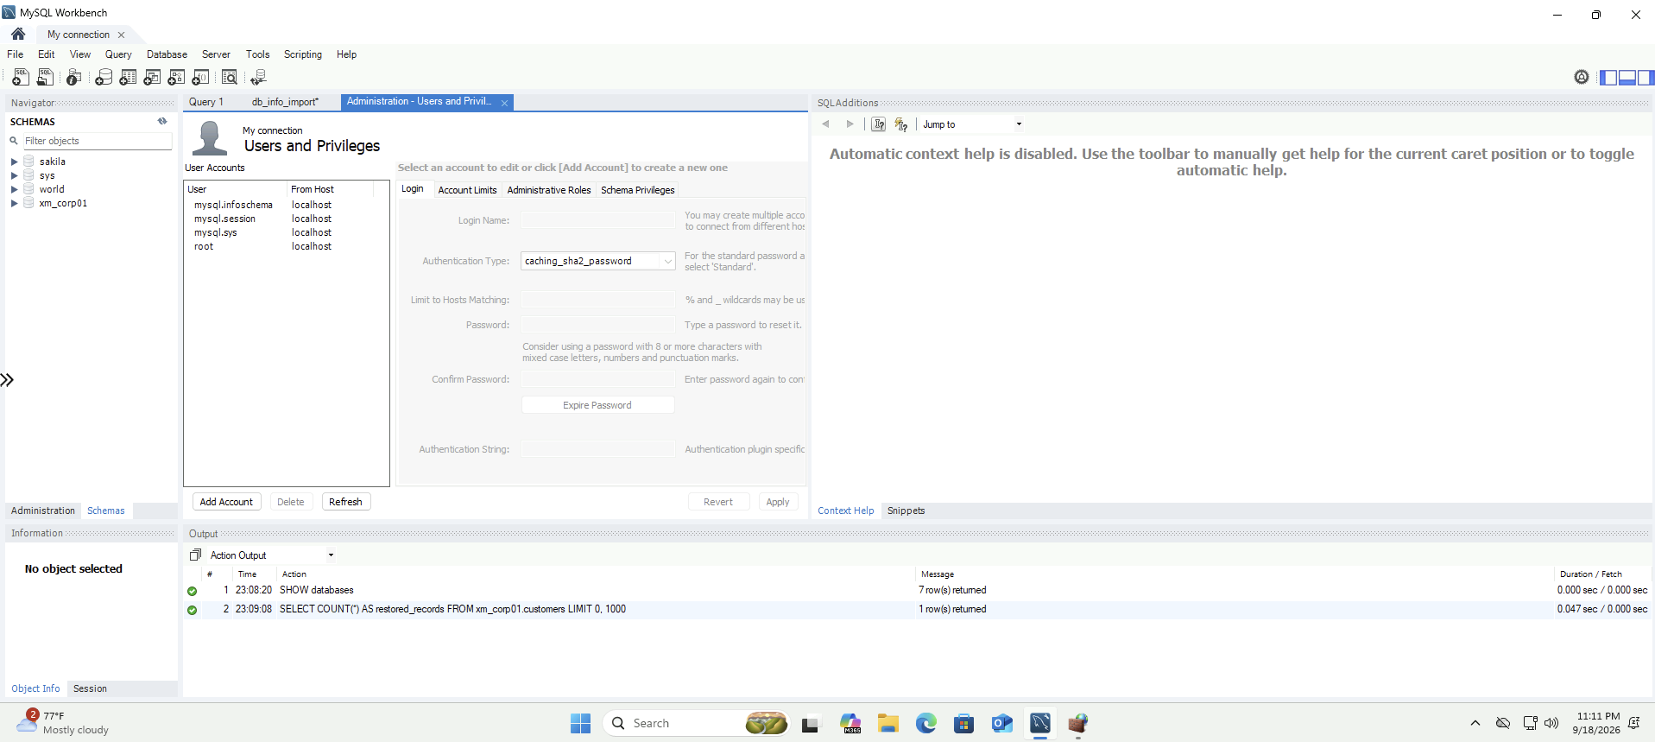
Figure 12. MySQL lists root with localhost access. The xm_corp01 schema is present and a customer-count query completed, but its returned count is not visible.
Source: P9-18 - MySQL Remote Root Access Removed.png

Account hardening and malware verification
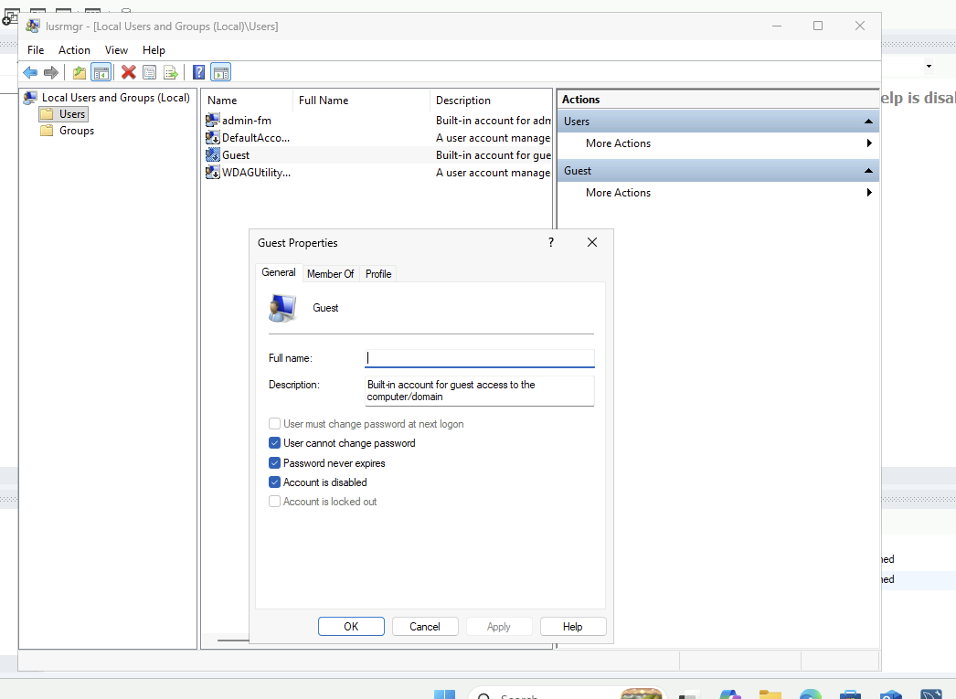
Figure 13. The Guest account is disabled in the recovery configuration.
Source: P9-19 - Guest Account Disabled.png
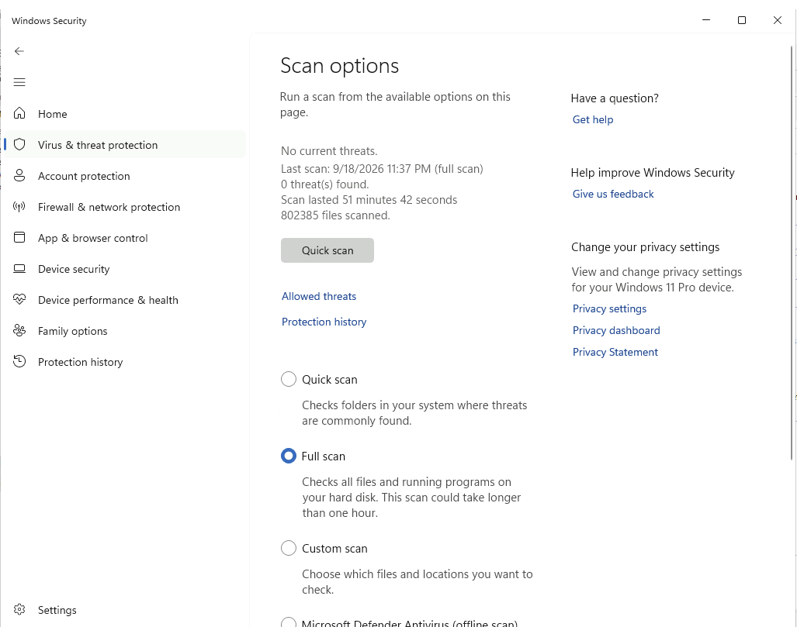
Figure 14. Windows Security records a completed full scan with 0 threats found, 802,385 files scanned and a duration of 51 minutes 42 seconds.
Source: P9-20 - Full Defender Malware Scan Completed.png

9 Evidence register and supporting queries
The evidence set comprises endpoint exports, MySQL audit exports, MDE investigation packages and incident-response screenshots. The package comparison is integrated into Sections 5–7. Selected screenshots are embedded at their relevant sections, with the original filename recorded under each figure. Captions describe the visible content where a source filename is misleading.
Evidence artifact | Use in this report
P7-VM-Logon-Logs-corp-neo10-f777.csv | Successful Windows logons and account context
P7-VM-Process-Logs-corp-neo10-f777.csv | Process execution and command lines
P7-VM-Process-Logs-corp-neo10-f777 (admin only).csv | Administrator process activity
P7-VM-Registry-Logs-corp-neo10-f777.csv | Executable-handler registry modification
P7-VM-File-Logs-corp-neo10-f777.csv | File activity
P7-VM-Network-Logs-corp-neo10-f777.csv | Host network activity, failed RDP lateral-movement attempts, service exposure and suspicious-process outbound connections
P7-21 - DeviceNetworkEvents Full Incident Window Query.png | Documents the DeviceNetworkEvents incident-window investigation query
P7-22 - DeviceNetworkEvents Full Incident Window Results.png | Export view showing replacement-host traffic; original-host findings are drawn from the CSV
P7-MySQL-Authentication-Logs-corp-neo10-f777m.csv | MySQL connection and authentication activity
P7-MySQL-Query-Logs-corp-neo10-f777m.csv | MySQL enumeration, reads, destructive statements and extortion note
Pre-investigation package.zip | Baseline host state before recorded exposure
Post-Breach.zip | Post-compromise state and historical execution artifacts
Defender and Sentinel incident evidence | Detection context and original alert severity
Phase 8 and Phase 9 screenshots | Containment, eradication, recovery and hardening

Query appendix
Appendix A records nine KQL queries used during the investigation. A1–A8 are documented in the Phase 7 notes; A9 is supported by the network-query screenshot and CSV export. They cover Windows logons, process, file, registry and network activity, and MySQL authentication and SQL statements.
Original filters, table names and time parameters are retained. Run each complete query separately. A1–A8 have no upper time bound: reruns require an incident end time and original-host identity checks to avoid replacement-host traffic. A9 includes both hosts and requires the LocalIP scoping described below. TimeGenerated is the Sentinel field; MySQLAudit_CL is the custom table.
The file and registry queries use 15 September 2026 at 12:29:04Z as their search threshold. The logon export records a Network logon at 12:29:04 and a RemoteInteractive logon at 12:29:06. Query literals use UTC; screenshots and CSVs retain displayed times without timezone metadata. The endpoint timezone remains unresolved.

Appendix A Queries used during the investigation
These nine queries document the investigation method. A1–A8 come from the Phase 7 notes; A9 is evidenced by the network-query capture and export. Run each query as a separate block, including its let statements.

A1 Windows account logons
Reviews Administrator and Guest logon activity after the recorded exposure threshold, including event outcome, source IP and logon type.
// Virtual Machine Logons
let MyDevice = "corp-neo10-f777";
let ServerVulnerableDateTime = todatetime("2026-09-14T22:14:02Z");

DeviceLogonEvents
| where TimeGenerated > ServerVulnerableDateTime
| where DeviceName == MyDevice
| where AccountName in~ ("administrator", "guest")
| project TimeGenerated, RemoteIP, AccountName, DeviceName, ActionType, LogonType

A2 Successful Windows logons
Filters the account logon review to successful events. LogonType distinguishes remote-interactive sessions from other successful authentication events (Figure 5).
let MyDevice = "corp-neo10-f777";
let ServerVulnerableDateTime = todatetime("2026-09-14T22:14:02Z");

DeviceLogonEvents
| where TimeGenerated > ServerVulnerableDateTime
| where DeviceName == MyDevice
| where AccountName in~ ("administrator", "guest")
| where ActionType == "LogonSuccess"
| project TimeGenerated, RemoteIP, AccountName, DeviceName, ActionType, LogonType

Appendix A Process activity queries

A3 Host process activity
Reviews process execution after exposure, including commands, initiating processes and file paths.
// Virtual Machine Process Activity
let MyDevice = "corp-neo10-f777";
let ServerVulnerableDateTime = todatetime("2026-09-14T22:14:02Z");

DeviceProcessEvents
| where TimeGenerated > ServerVulnerableDateTime
| where DeviceName == MyDevice
| project TimeGenerated,
AccountName,
DeviceName,
ProcessCommandLine,
InitiatingProcessCommandLine,
FolderPath,
FileName
| order by TimeGenerated desc

A4 Administrator process activity
Narrows the process review to the Administrator account. This review identified Masscan, WinPcap and related execution activity (Figure 6).
// Administrator Process Activity
let MyDevice = "corp-neo10-f777";
let ServerVulnerableDateTime = todatetime("2026-09-14T22:14:02Z");

DeviceProcessEvents
| where TimeGenerated > ServerVulnerableDateTime
| where DeviceName == MyDevice
| where AccountName == "administrator"
| project TimeGenerated,
AccountName,
DeviceName,
ProcessCommandLine,
InitiatingProcessCommandLine,
FolderPath,
FileName
| order by TimeGenerated desc

Appendix A File and registry queries

A5 File activity
Reviews file events from the recorded first-logon search threshold, including the initiating account, command line and affected path.
let FirstSuccessfulLogonTime = todatetime("2026-09-15T12:29:04Z");
let MyDevice = "corp-neo10-f777";

DeviceFileEvents
| where TimeGenerated >= FirstSuccessfulLogonTime
| where DeviceName == MyDevice
| project TimeGenerated,
InitiatingProcessAccountName,
InitiatingProcessCommandLine,
FolderPath,
FileName,
DeviceName
| order by TimeGenerated desc

A6 Registry activity
Reviews registry events from the same threshold, including value data and initiating commands. This supported investigation of the executable-handler modification.
let FirstSuccessfulLogonTime = todatetime("2026-09-15T12:29:04Z");
let MyDevice = "corp-neo10-f777";

DeviceRegistryEvents
| where TimeGenerated >= FirstSuccessfulLogonTime
| where DeviceName == MyDevice
| project TimeGenerated,
InitiatingProcessAccountName,
InitiatingProcessCommandLine,
ActionType,
RegistryKey,
RegistryValueName,
RegistryValueData,
DeviceName
| order by TimeGenerated desc

Appendix A MySQL authentication query

A7 MySQL authentication
Extracts connection IDs, accounts and source IPs from MySQL audit messages, and assigns authentication outcome labels.
// MySQL Authentication
let MyDevice = "corp-neo10-f777m";
let MyTimeframe = datetime(2026-09-14T22:14:02Z);

let FailedConnections =
MySQLAudit_CL
| where TimeGenerated > MyTimeframe
| extend RawData = replace_string(RawData, "\t", " ")
| extend DeviceName = tostring(split(_ResourceId, "/")[-1])
| where DeviceName == MyDevice
| where RawData has "Access denied"
| extend ConnectionId = extract(@"^\S+\s+(\d+)\s+Connect", 1, RawData)
| where isnotempty(ConnectionId)
| distinct ConnectionId;

MySQLAudit_CL
| where TimeGenerated > MyTimeframe
| extend RawData = replace_string(RawData, "\t", " ")
| extend DeviceName = tostring(split(_ResourceId, "/")[-1])
| where DeviceName == MyDevice
| where RawData has "Connect"
| extend ConnectionId = extract(@"^\S+\s+(\d+)\s+Connect", 1, RawData)
| extend ActionType =
case(
RawData has "Access denied", "LogonFailure",
ConnectionId in (FailedConnections), "Ignore",
"LogonSuccess"
)
| where ActionType != "Ignore"
| extend RawData = replace_string(RawData, "\t", " ")
| extend Username = replace_string(
tostring(split(tostring(split(RawData, "@")[0]), " ")[-1]),
"'",
""
)
| extend IpAddress = replace_string(
tostring(split(split(RawData, "@")[1], " ")[0]),
"'",
""
)
| project TimeGenerated,
DeviceName,
Username,
IpAddress,
ActionType,
RawData
| order by TimeGenerated desc
Interpretation: LogonSuccess is assigned by the helper query rather than supplied as a native MySQL outcome. The Phase 7 analysis identified four blank Connect records among 49 success-labelled rows; only 45 contained explicit successful root connections. Validate the underlying RawData before treating a labelled row as confirmed access.

Appendix A MySQL query activity

A8 SQL statements after exposure
Extracts SQL query events for the MySQL resource after exposure. Results supported the database enumeration, table-access, destructive-command and extortion findings (Figure 4).
// Filtering Queries
let MyDevice = "corp-neo10-f777m";
let ServerVulnerableDateTime = todatetime("2026-09-14T22:14:02Z");

MySQLAudit_CL
| where TimeGenerated > ServerVulnerableDateTime
| where RawData has "Query"
| extend RawData = replace_string(RawData, "\t", " ")
| extend DeviceName = tostring(split(_ResourceId, "/")[-1])
| where DeviceName == MyDevice
| extend ActionType = "Query"
| extend Query = split(RawData, "Query")[1]
| project TimeGenerated, DeviceName, ActionType, Query, RawData
| order by TimeGenerated desc
Interpretation: The general query log records statements issued, not their returned data or the success of every operation. SELECT statements and ransom-note claims therefore do not independently prove exfiltration.
A1–A8 source: PHASE 7 (notes) - Helper Queries and AI Analysis (1).docx. A9 source: P7-21 query capture and P7-VM-Network-Logs-corp-neo10-f777.csv.

Appendix A Network activity query

A9 DeviceNetworkEvents incident-window review
Reviews DeviceNetworkEvents across the incident window for corp-neo10-f777, capturing local and remote endpoints, connection outcome, protocol and initiating-process context. The result set includes both the compromised host (10.1.0.10) and later replacement-host traffic (10.1.0.105) because the replacement reused the endpoint naming convention; compromise analysis in this report treats 10.1.0.10 as the original host.
let MyDevice = "corp-neo10-f777";
let StartTime = datetime(2026-09-14T22:14:02Z);
let EndTime = datetime(2026-09-18T22:41:13Z);

DeviceNetworkEvents
| where TimeGenerated between (StartTime .. EndTime)
| where DeviceName == MyDevice
| project TimeGenerated,
ActionType,
LocalIP,
LocalPort,
RemoteIP,
RemotePort,
RemoteUrl,
Protocol,
InitiatingProcessAccountName,
InitiatingProcessFileName,
InitiatingProcessFolderPath,
InitiatingProcessCommandLine
| order by TimeGenerated asc
Interpretation: The network review identified eight failed RDP attempts initiated by mstsc.exe under the Administrator account, successful outbound connections from ._cache_Massscan_GUI.exe to www.ipdeny.com, and successful outbound connections from Synaptics.exe to freedns.afraid.org and Google-hosted services. Network communication is established; successful lateral compromise, confirmed C2 and data exfiltration are not.

Network activity evidence
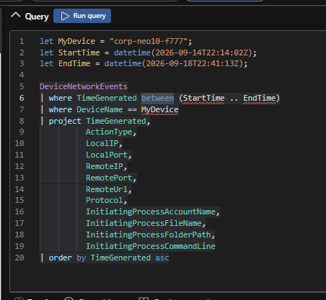
Figure A1. DeviceNetworkEvents query used for the incident-window export, including the device filter, local endpoints and process context reproduced in A9.
Source: P7-21 - DeviceNetworkEvents Full Incident Window Query.png
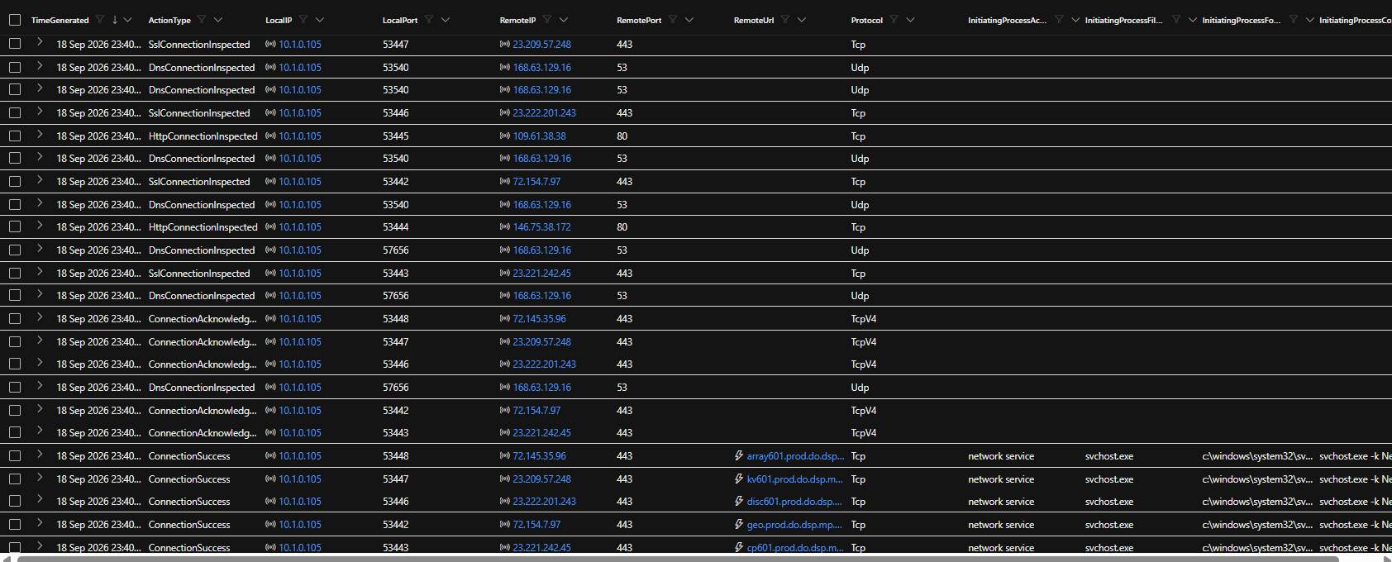
Figure A2. Network export results showing replacement-host traffic from 10.1.0.105. These visible rows do not demonstrate the original host’s malicious activity; the findings use the CSV rows for 10.1.0.10.
Source: P7-22 - DeviceNetworkEvents Full Incident Window Results.png

